9. Develop a system using UML for E-Book Management System. It should be designed to manage the books that were read through the internet. That should consist of the details of the e-book that were read by the user online. It will be controlled by the central system. This system should act as a backup of all details together.

Class diagram: -

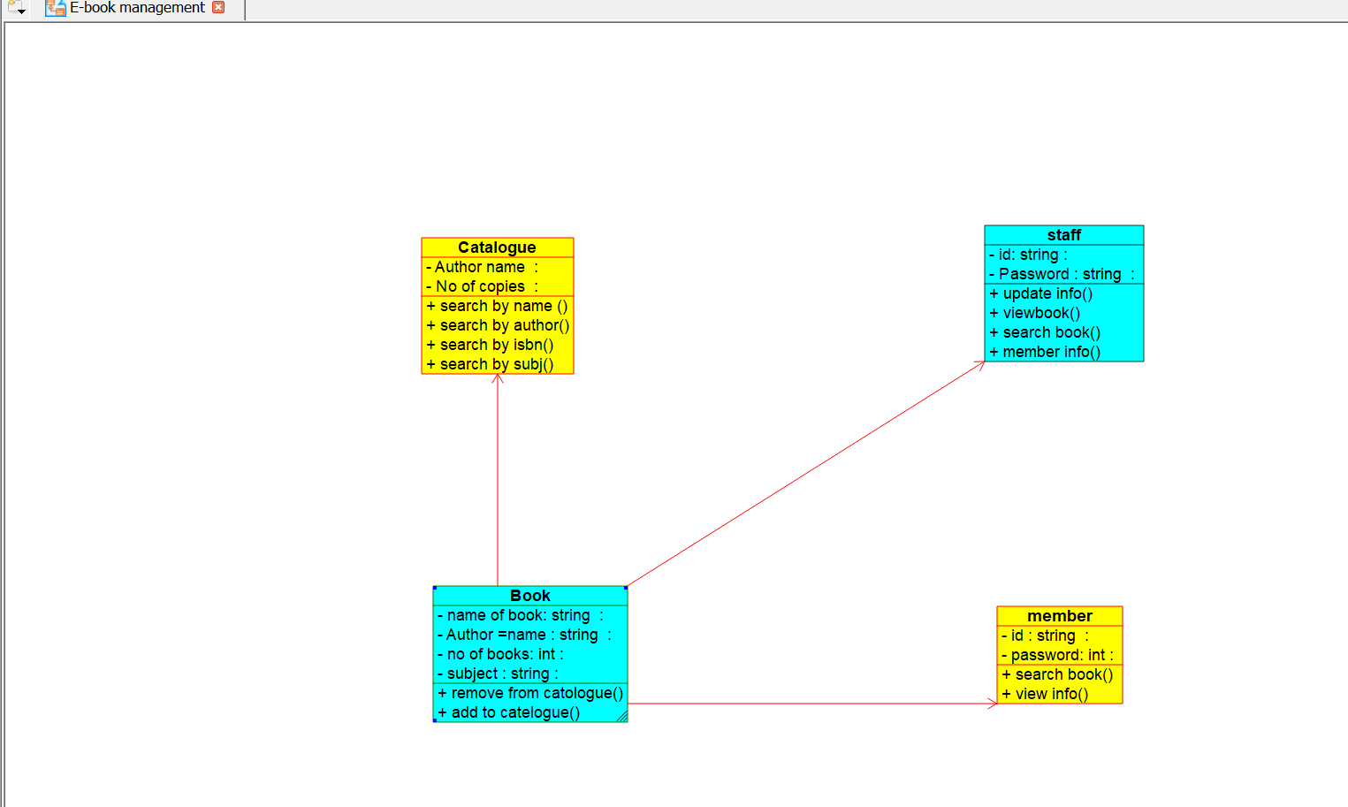

Code generation:-

